Associated Christian Schools
2020 Cardus Education Survey Australia

Examining the Impact of Findings for ACS member schools
A Handbook for Further Discussion

WHAT ACS VALUES FROM THIS RESEARCH
- the value of collaboration
  - ACS values the leadership shown by Queensland colleague, Dr Darren Iselin as lead Australian researcher for the Consortium and by ACS ED/PRO Dr Lynne Doneley representing ACS on the Consortium
- the value of leveraging
  - ACS values the leverage gained by collaborating with a reputable established research body like Cardus
- the value of ACS policy aligning Christian schooling within independent schooling
  - ACS values all sectors of schooling and particularly values its place within the non-government sector which it shares with Independent and Catholic schooling
- the value of the Christian school sector’s contribution to the common good
  - ACS values the values the validation of all sectors as active contributors to the social fabric of Australian society (the common good) as a uniquely Australian achievement
- the value of government support for education (via recurrent and capital funding)
  - ACS values the role of government funding in creating a sizeable Australian Christian schooling sector of exemplary quality that is contributing to social capital (the common good).

Source Documents

There are four resource documents available on the Cardus Education Survey Australia website
The Full Report

Supplementary Results

The Summary Report

Infographic

Suggestion for use

- The Summary Report + Infographic may be most useful for school discussions

- The Full Report may be most useful for individual reading

- The Supplementary Results may be most useful for those wishing to analyse particular data more closely

For wider reading on the Cardus Survey approach
Previous Cardus Research Reports for North America can be found at the bottom of this webpage

FURTHER THINKING ON THE IMPACT OF FINDINGS
Each section refers to a chapter in the Cardus Education Survey Australia Report

The purpose of the research was not to make inter-sectoral comparisons. However, what might the Christian sector learn from sector comparison that could strengthen its Christian and common good purpose?
ACS has several papers to be found in eBook 1 (2019) and eBook 2 (2020) addressing these topics which may be helpful to consult (these are hyperlinked below).

- FORMATION

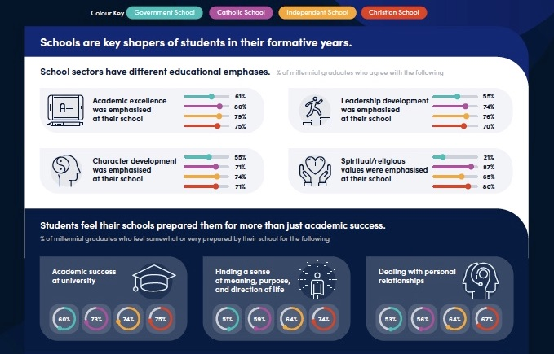

  - Do our schools need to strengthen academic focus? How?
ACS eBook 1 (2019) section 2: ‘Christian education: both truly Christian, and truly an excellent education’ has 5 papers that may help in addressing this topic
ACS eBook 2 (2020) chapter 2: ‘Answering the call to know, love and challenge students in a Christian school’ 3: ‘Australia’s 2018 PISA results – a story that just won’t go away’, and 4: ‘Evidence, a key in school improvement: Is there evidence of consistency of academic outcomes?’ are papers also addressing this topic
  - Do our schools need to strengthen character and leadership development? How?
ACS eBook 1 (2019) section 1: ‘Holistic formation: ‘Integrating the life of the mind, the life of the spirit, & the life of work’ may help in addressing this topic
ACS eBook 2 (2020) chapters 5: ‘Lessons in excellence from Deuteronomy and Daniel’, and 6: ‘A taste of Old Testament wisdom from the Commonwealth Chief Rabbi: from ‘Lessons in Leadership’ ’ are papers that may help in addressing this topic
  - Do our schools need to more purposefully inculcate religious values? How?
ACS eBook 1 (2019) sections 1: ‘Holistic formation: ‘Integrating the life of the mind, the life of the spirit, & the life of work’, 3: ‘Worldview thinking: where does that lead us?’, 4: ‘Christian education for a pluralist society’, and 5: ‘Building a case for philanthropy in Christian schools’ have papers that may help in addressing this question
ACS eBook 2 (2020) chapters 2: ‘Answering the call to know, love and challenge students in a Christian school’ addresses this topic
  - What is currently done really well?
- WORK

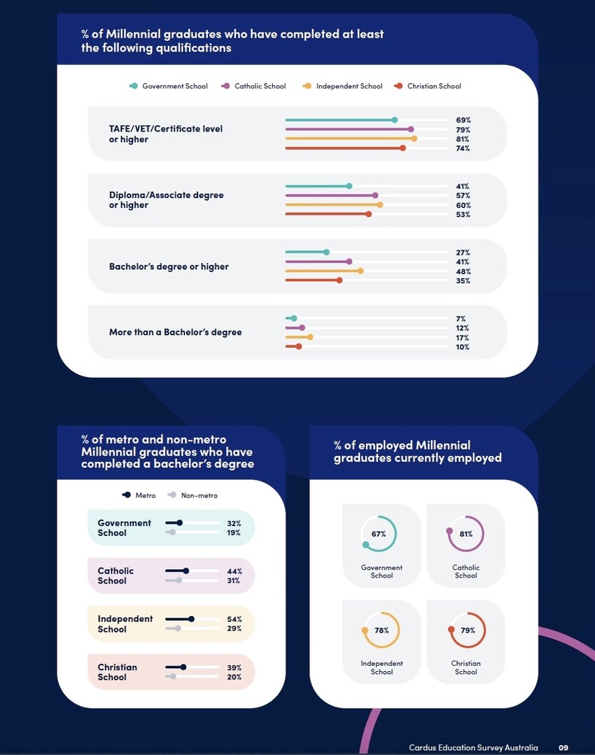

  - Why might higher education be valued more by alumni of Catholic and Independent sectors?
ACS eBook 1 (2019) section 6: ‘Evangelical Christian school leaders engaging with, and learning from, Catholics ’ has 3 papers that may help in addressing this topic
  - Lower participation of non-metropolitan students in higher education is a key research finding, ACS proposes a collaborative project with CHC seeking to lift participation rates of alumni in regional and remote areas in higher and further education. How?
  - How might ACS member schools promote student thinking about a longer-term view of higher and further education eg masters’ degrees?

- BELONGING
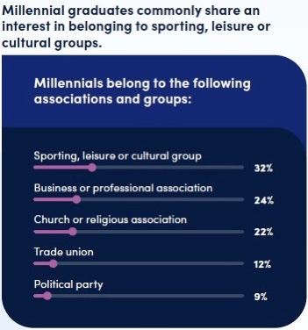

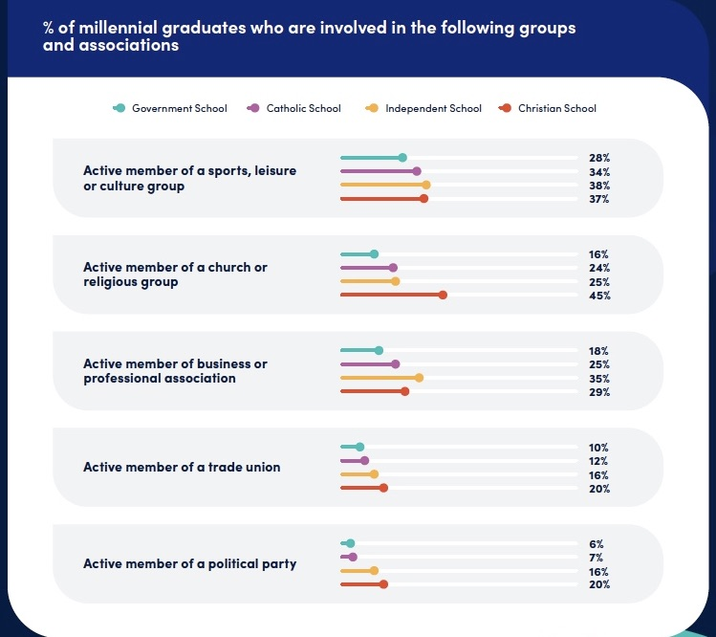

  - How might ACS members help their students better prepare for longer-term participation in civic and business life as alumni?
ACS eBook 1 (2019) sections 4: ‘Christian education for a pluralist society, 5: ‘Building a case for philanthropy in Christian schools’ and 6: ‘Evangelical Christian school leaders engaging with, and learning from, Catholics’ have papers that may help in addressing this topic
- GENEROSITY

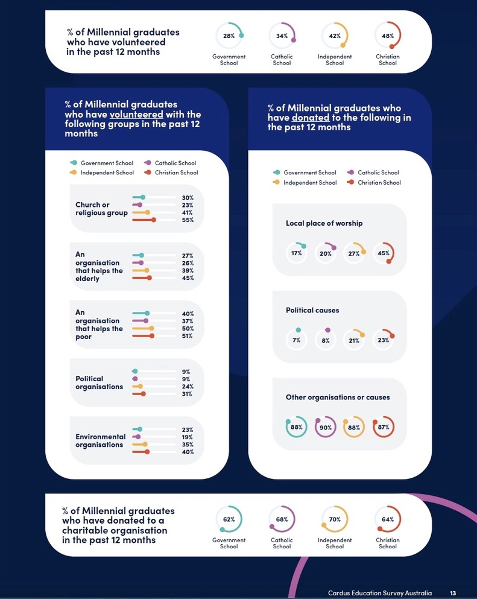

  - How might ACS members help their students better prepare for longer-term participation in civic and business life as alumni philanthropists (donors) of both time and money?
ACS eBook 1 (2019) section 5: ‘Building a case for philanthropy in Christian schools’ has papers that may help in addressing this topic

- FAMILY

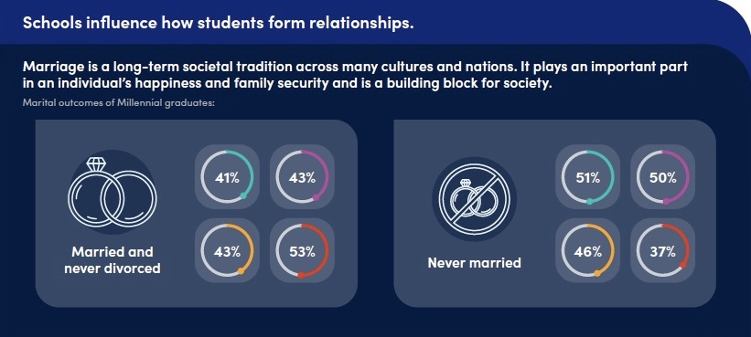

  - How might ACS member schools better communicate the historic Christian view of marriage to their students?

- RELIGION
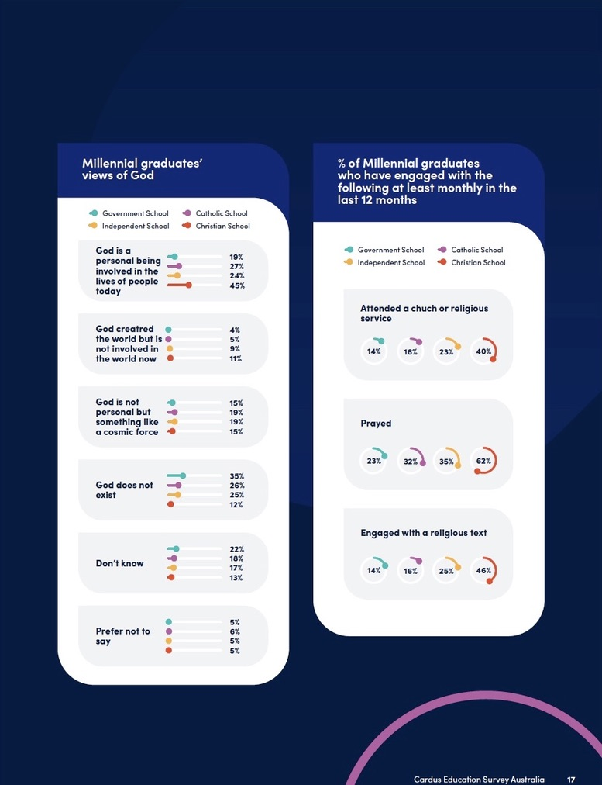
  - How might ACS member schools improve the evangelisation of their students?
ACS eBook 1 (2019) sections 1: ‘Holistic formation: ‘Integrating the life of the mind, the life of the spirit, & the life of work’, 3: ‘Worldview thinking: where does that lead us?’, and 4: ‘Christian education for a pluralist society’, have papers that may help in addressing this question
  - How might ACS member schools improve the commitment of students and alumni to their churches?
ACS eBook 1 (2019) sections 1: ‘Holistic formation: ‘Integrating the life of the mind, the life of the spirit, & the life of work’ , 5: ‘Building a case for philanthropy in Christian schools’ and 6: ‘Evangelical Christian school leaders engaging with and learning from Catholics’ have papers that may help in addressing this topic
ACS eBook 2 (2020) chapters 2: ‘Answering the call to know, love and challenge students in a Christian school’, and 5: ”Lessons in Excellence from Deuteronomy and Daniel’ are papers that may help in addressing this topic
  - What might ACS member schools learn from the Catholic sector in placing a higher value in the promotion of life-long commitment to education and faith?
ACS eBook 1 (2019) section 6: ‘Evangelical Christian school leaders engaging with and learning from Catholics” has 3 papers that may help in addressing this topic

